Email notification system: AWS Newsletter Service

**Table of Contents**

|  |  |  |
| --- | --- | --- |
| **No.** | **Topic** | **Page No.** |
| 1. | Introduction to AWS Newsletter Service | 4 |
| 2. | Problem Statement | 4 |
| 3. | Key Objectives | 5 |
| 4. | Tools & Technology used | 5 |
| 5. | Workflow Architecture Model | 6 |
| 6. | Key Features of the Automated Newsletter Service | 7 |
| 7. | Website to Subscribe to the Newsletter | 8 |
| 8. | Newsletter Sent to the Subscriber via AWS SES | 9 |
| 9. | Verified Subscriber’s Email and Sample Test Email | 10 |
| 10 | S3 Buckets Created and DynamoDB Storage | 11 |
| 11 | Summary Evaluation | 11 |

Introduction to AWS Newsletter Service

To gain attention in today’s world, one must have the ability to spread a message to a broad public effectively both businesses and organizations. Still email newsletters are considered to be an effective means for reaching the subscribers, providing them with important information, and stimulating their activity. Nonetheless, coordinating and disseminating newsletters can be quite a challenge especially for a large organization.

In order to overcome these challenges, the AWS Newsletter Service has been designed. The proposed solution is based on AWS with the goal to fully automatise the newsletter process, including the content creation and personalisation, delivery and analytics. Altogether, I have built a flexible and extensible platform with the usage of S3, Lambda, API Gateway, SES, and DynamoDB, which is suitable as a foundation to serve multiple millions of subscribers and provide highly relevant newsletters.

Using our service, you can instantly create and send newsletters, target sent material according to the subscriber’s preference or even analyze basic statistics to improve your campaigns. Our solution guarantees the sender’s mail delivery, gracefully processes bounce and error conditions, and offers useful information to optimize the next campaign.

Problem Statement

The **AWS Newsletter Service** is incorporated with features as a reliable and efficient method of delivering personalized newsletters to numerous subscribers. By using various AWS services including S3, Lambda, API Gateway, SES and DynamoDB, we have optimized our approach of performing email deliveries, therefore guaranteeing our ability to deliver a high volume of emails. Traditional newsletter delivery modes present a number of problems, such as: PDF and Word files do not work well for submitting newsletters manually, a traditional newsletter cannot be adapted to for a large recipient list, newsletters cannot be easily customized for individual listeners, traditional delivery of newsletters is an incredibly slow process, and support for newsletters lacks statistics gathering. Being completely remote, offering options for customization of content and fully digital analytics as well as streamlining the overall process, our service enables businesses to target their audience and see directly defined outcomes.

Key Objective

1. **Automate Newsletter Delivery:** Optimize the process of delivering newsletters at predefined frequency or on performance of certain activities.
2. **Personalize Content:** Adapt newsletter content depending on subscriber preferences and actions taken with the newsletter itself.
3. **Ensure Reliable Delivery:** Messages will be delivered at the highest rates through proper error checking and relocation.
4. **Monitor and Analyze Performance:** It helps to monitor such important indicators as open rates, click-through rates, bounce rates in order to fine-tune future endeavors.
5. **Scale Efficiently:** It means designing the system to be able to cater to the increase in the number of subscribers and volumes of newsletters without reducing the efficiency of the service.

Tools & Technology Used

1. **S3:** Saves stores newsletter templates and static assets which can be easily accessible, scalable and to host websites where only read permission is required.
2. **Lambda:** Performs the serverless function of processing newsletter data to filter content and to send out emails.
3. **Gateway API:** Employs a RESTful API to allow endpoints for subscriptions, preference and other newsletter contents.
4. **SES:** A cost powerful mass mailer with full features including bounce management, complaint tracking, and delivery statistics.
5. **DynamoDB:** Stores subscriber information, preference and delivery history to help to Call up or modify stored information easily.

Workflow Architecture Model

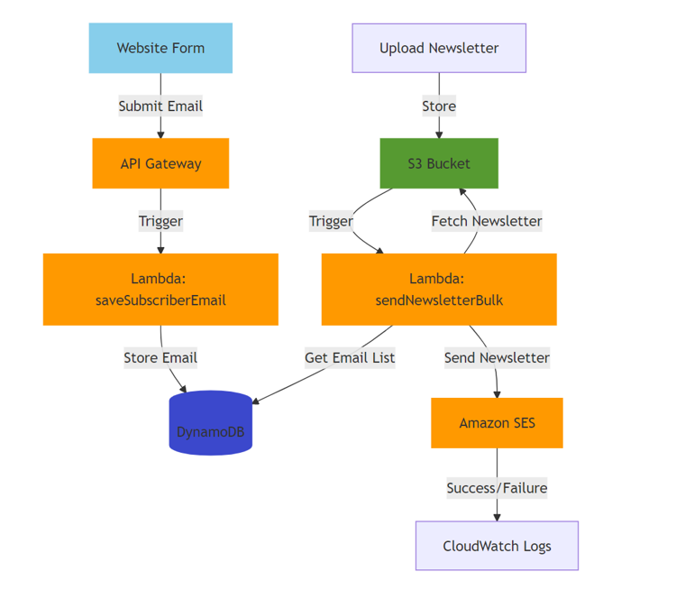

The diagram depicts a fully automated newsletter service built using various AWS services:

1. **Website Form:** Users submit their email addresses to subscribe to the newsletter.
2. **API Gateway:** Acts as the interface, receiving email submissions and triggering Lambda functions.
3. **Lambda (saveSubscriberEmail):** Stores the submitted email address in a DynamoDB table.
4. **DynamoDB:** Stores the list of subscribed email addresses.
5. **S3 Bucket:** Stores the newsletter content in a static format (e.g., HTML).
6. **Lambda (sendNewsletterBulk):** Fetches the newsletter content from S3, retrieves the email list from DynamoDB, and sends the newsletter to all subscribers using Amazon SES.
7. **Amazon SES:** Delivers the newsletter emails to subscribers.
8. **CloudWatch Logs:** Tracks the success or failure of each email delivery and logs any errors.

**Key Features of the Automated Newsletter Service**

This architecture offers several key features:

1. **Automation:** In fact the entire process right from the signing up of the subscriber to the delivery of the actual email is fully automated.
2. **Scalability:** Flexibility can thus be easily accessed to accommodate for a growing subscriber base through the use of AWS services. Also, the system can easily accommodate a growing number of subscribers hence it can easily handle increased loads.
3. **Reliability:** AWS offers a very reliable service to ensure that newsletters are delivered and at the right time.
4. **Personalization:** Not illustrated but very possible in the diagram is the prospect of customizing newsletters depending on the preferences of the subscriber or even segmentation.
5. **Analytics:** Within CloudWatch, you can log all email delivery performance and monitor such statistics as open rates, cTRs, and bounce rates.

Website to Subscribe to the Newsletter

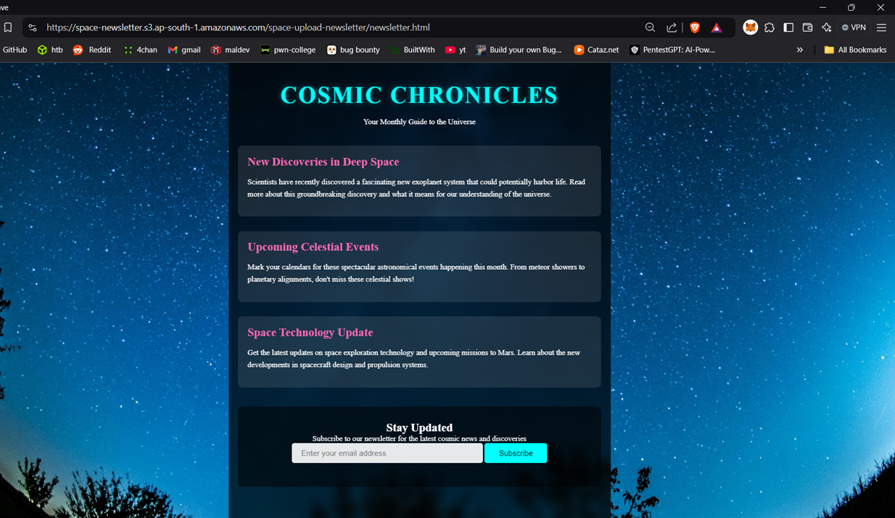

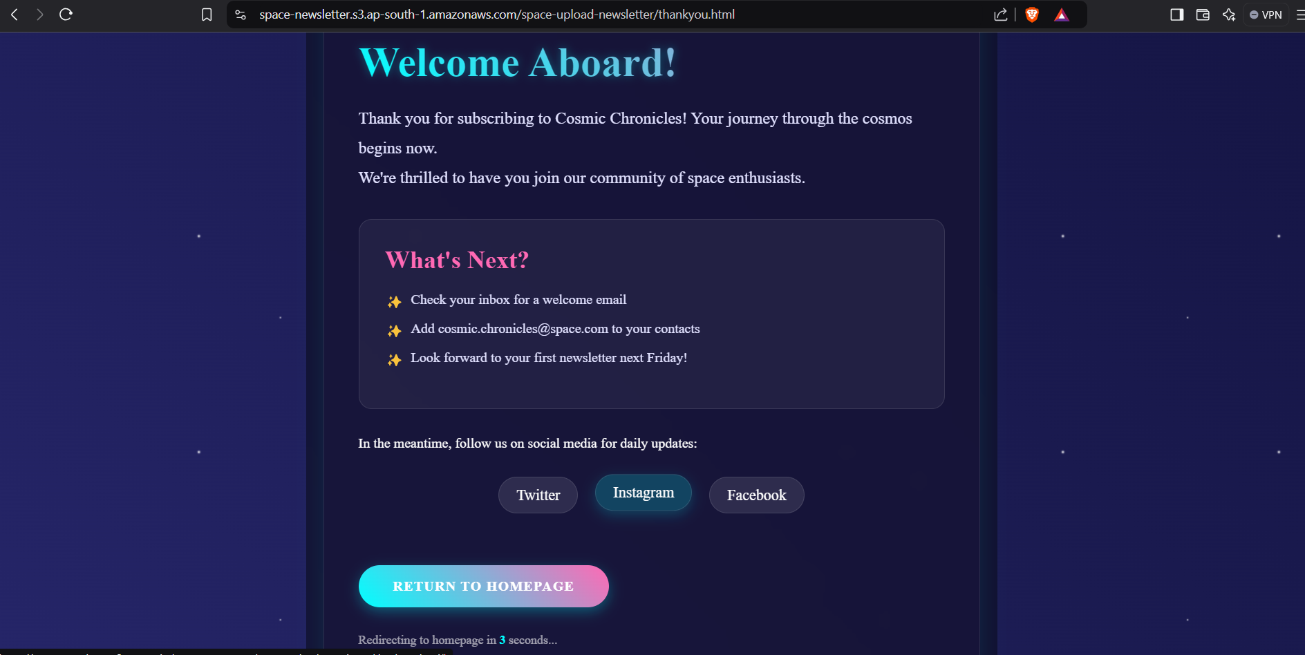

**Cosmic Chronicles** is a space odyssey, brought right to your inbox. This newsletter platform was designed to integrate the deep usefulness of AWS and deliver engaging experiences each time it is used.

**How it Works:**

1. **Subscription:** Members register their visit through our website that is located on S3, which is a secure and highly available storage.
2. **Data Storage:** Subscriber data is safely archived in DynamoDB, a highly effective NoSQL setting.
3. **Content Creation:** We have created imaginative astronomical content, which is hosted on S3.
4. **Automated Delivery:** For example, lambda functions that are initiated by a schedule or by certain events first pull down the newest content from S3 and then send tailored newsletters through SES.
5. **Performance Tracking:** Tempest keeps track of the whole process, on delivery rates, on open rates, on click-through rates.

Newsletter Sent to the Subscriber via AWS SES

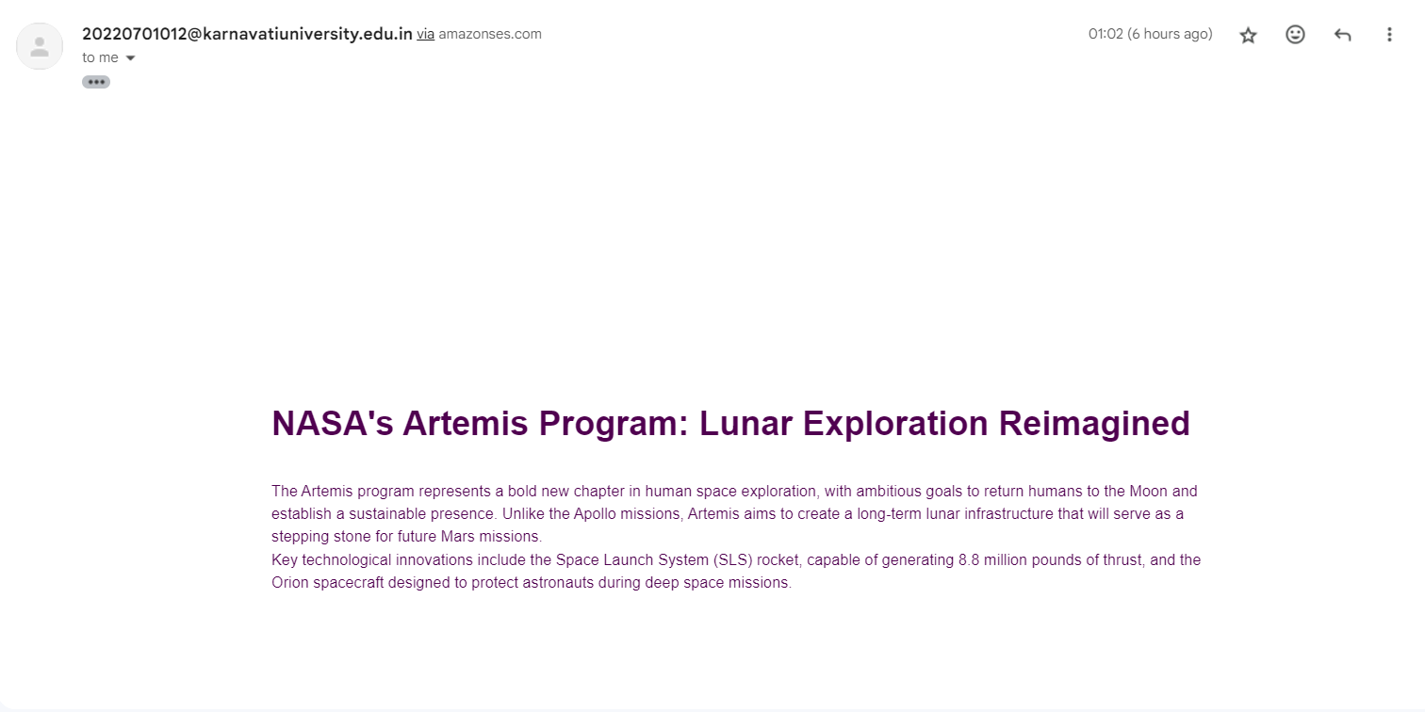

The ‘Cosmic Chronicles’ email newsletter provides a brief but accurate and up-to-date account of current and emerging trends in space and beyond exploration. It points out the targets of NASA’s Artemis initiative that is planning to send people back to the Moon and make them permanent residents. Moreover, the newsletter also provides information on both formal and science news and updates including the latest achievement of James Webb Space Telescope including observation of the most distant Galaxy and detailed mapping of different exoplanets’ atmospheres. Attractively and concisely, the present newsletter draws the reader’s attention towards these important space missions and scientific discoveries.

Verified Subscriber’s Email and Sample Test Email

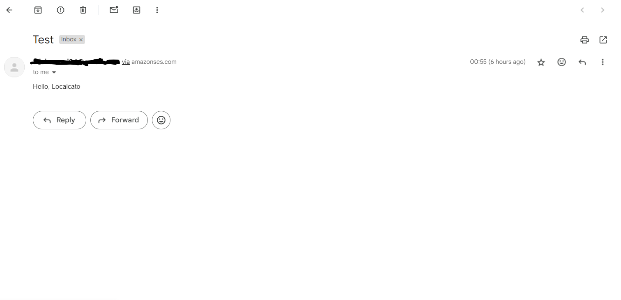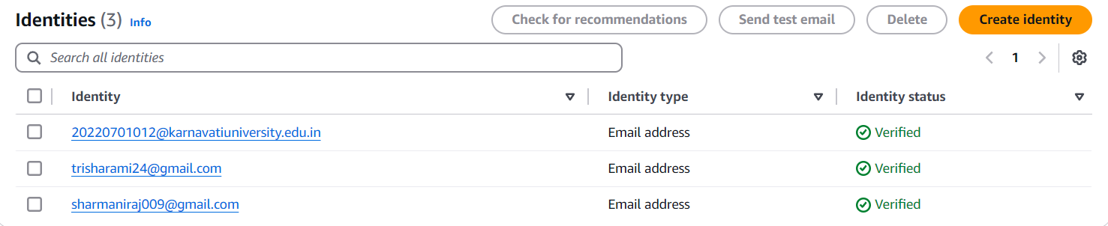

The Identities pane lists your domains, subdomains, and email address identities. All identities must be verified before you use them to send email in Amazon SES.

S3 Buckets Created and DynamoDB Storage

This showcases three Amazon S3 buckets in the Asia Pacific (Mumbai) Region (`ap-south-1`), each with a distinct role in a newsletter service architecture. The **my-email-subscription-page** bucket likely hosts the subscription page, **newsletter-templates-uit** stores reusable email templates, and **space-newsletter** contains content or assets for the "Cosmic Chronicles" newsletter. These buckets integrate with other AWS services, such as Lambda and SES, to automate newsletter delivery while **IAM Access Analyzer** ensures proper access control.

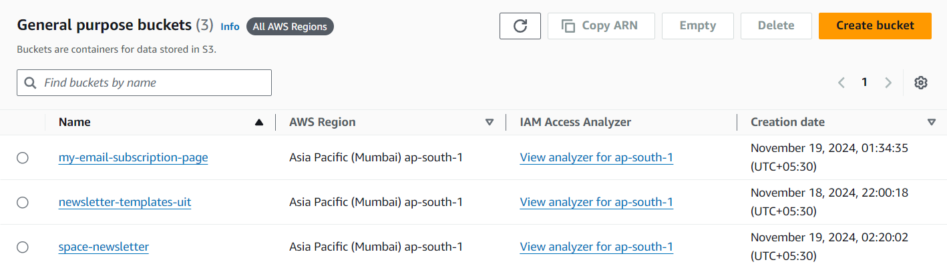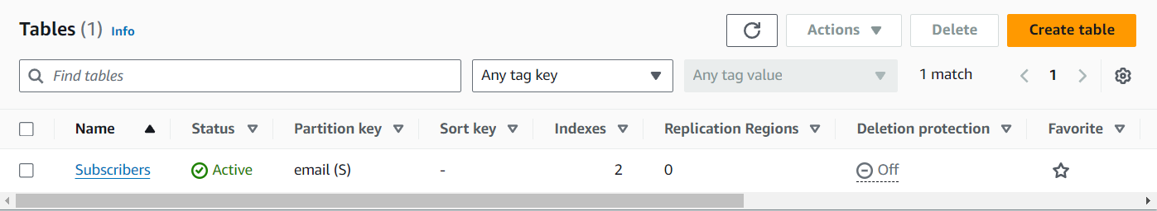This DynamoDB table, named **“Subscribers”**, is active and uses `email` (string) as the partition key to uniquely identify items. It includes two indexes for optimized querying and is not regionally replicated. Likely part of a newsletter service, it stores subscriber details and integrates with AWS services like Lambda and SES for automated email management.

Summary Evaluation

The AWS Newsletter Service has an enhanced, elastic, and completely hands-off architecture for sending targeted newsletters to a broad audience Subscriber List while using S3, Lambda, API Gateway, SES, and DynamoDB. Focusing on classical problems of newsletter delivery, it provides a more reliable email delivery, possibilities to segment the audience and select the targeting content, as well as an opportunity to analyze the results and fine-tune the further performance. Its architecture provides fit subscription management, convenient content management, and useful tracking, so it is useful for businesses/organizations that are looking for ways to capture their targeted audiences. The integration of such services also improves the delivery reliability of the services, while also offering useful information to future campaign efforts – translating into an all new level of efficiency of email communication.

Another advantage worth mentioning is convenience achieved by the fact that the service allows for the recipient to define his/her interests, thus making newsletters more interesting. It is connected to Amazon SMS, which means that the primary deliverability rates and error management are guaranteed to be stable and efficient for the user. Also, with the help of CloudWatch Logs, analytics gives businesspeople an opportunity to observe open-rate, click-through-rate, and bounce-rate indicators to enhance future campaigns.

One of the most beneficial aspects of the system’s design is the strikingly seamless agility – the system can easily scale to accommodate more subscribers and elaborate workloads. It also eliminates the internality of the automation process with little or no human interference, therefore suitable for enhancing audiences for businesses and organizations. All in all, the AWS Newsletter Service model is a new standard of efficient, data-based, and individualized email advertising.